AI based discourse for Banking Industry

**Team ID : PNT2022TMID25247**

**Prior Knowledge :**

**What is AI?**

Artificial intelligence is the simulation of human intelligence processes by machines, especially computer systems. Specific applications of AI include expert systems, natural language processing, speech recognition and machine vision.

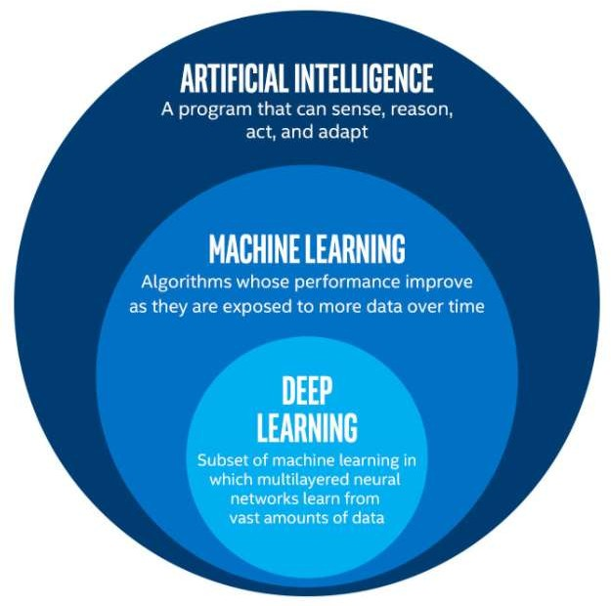

# What is NLP?

NLP stands for **Natural Language Processing**, which is a part of **Computer Science, Human language,** and **Artificial Intelligence**. It is the technology that is used by machines to understand, analyse, manipulate, and interpret human's languages. It helps developers to organize knowledge for performing tasks such as **translation, automatic summarization, Named Entity Recognition (NER), speech recognition, relationship extraction,** and **topic segmentation**.

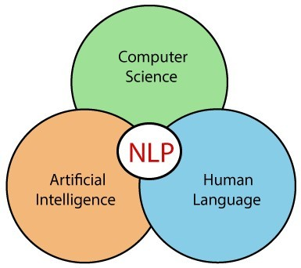

# Advantages of NLP

* NLP helps users to ask questions about any subject and get a direct response within seconds.
* NLP offers exact answers to the question means it does not offer unnecessary and unwanted information.
* NLP helps computers to communicate with humans in their languages.
* It is very time efficient.
* Most of the companies use NLP to improve the efficiency of documentation processes, accuracy of documentation, and identify the information from large databases.

# Disadvantages of NLP

A list of disadvantages of NLP is given below:

* NLP may not show context.
* NLP is unpredictable
* NLP may require more keystrokes.
* NLP is unable to adapt to the new domain, and it has a limited function that's why NLP is built for a single and specific task only.

# Components of NLP

There are the following two components of NLP -

# Natural Language Understanding (NLU)

Natural Language Understanding (NLU) helps the machine to understand and analyse human language by extracting the metadata from content such as concepts, entities, keywords, emotion, relations, and semantic roles.

NLU mainly used in Business applications to understand the customer's problem in both spoken and written language.

NLU involves the following tasks -

* It is used to map the given input into useful representation.
* It is used to analyze different aspects of the language.

# Natural Language Generation (NLG)

Natural Language Generation (NLG) acts as a translator that converts the computerized data into natural language representation. It mainly involves Text planning, Sentence planning, and Text Realization.

**Applications of NLP**

There are the following applications of NLP -

# Question Answering

Question Answering focuses on building systems that automatically answer the questions asked by humans in a natural language.



# Spam Detection

Spam detection is used to detect unwanted e-mails getting to a user's inbox.

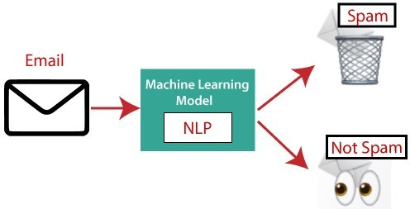

# Sentiment Analysis

Sentiment Analysis is also known as **opinion mining**. It is used on the web to analyse the attitude, behaviour, and emotional state of the sender. This application is implemented through a combination of NLP (Natural Language Processing) and statistics by assigning the values to the text (positive, negative, or natural), identify the mood of the context (happy, sad, angry, etc.)

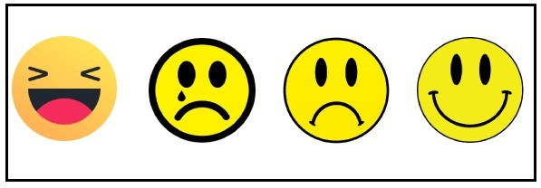

# Machine Translation

Machine translation is used to translate text or speech from one natural language to another natural language.

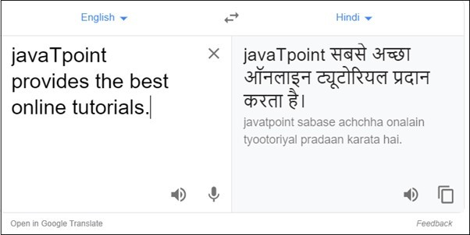

**Example:** Google Translator

# Spelling correction

Microsoft Corporation provides word processor software like MS-word, PowerPoint for the spelling correction.

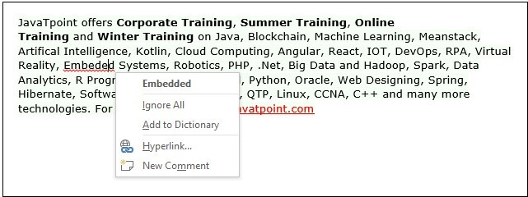

# Speech Recognition

Speech recognition is used for converting spoken words into text. It is used in applications, such as mobile, home automation, video recovery, dictating to Microsoft Word, voice biometrics, voice user interface, and so on.

# Chatbot

Implementing the Chatbot is one of the important applications of NLP. It is used by many companies to provide the customer's chat services.

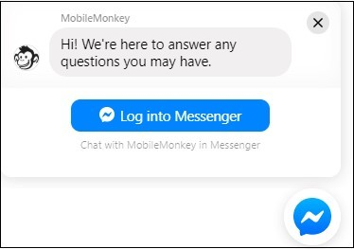

# Information extraction

Information extraction is one of the most important applications of NLP. It is used for extracting structured information from unstructured or semi-structured machine-readable documents.

# Natural Language Understanding (NLU)

It converts a large set of text into more formal representations such as first-order logic structures that are easier for the computer programs to manipulate notations of the natural language processing

# Python Flask :

Flask API provides the basic and advanced concepts of the Python Flask framework. Our Flask tutorial is designed for beginners and professionals.

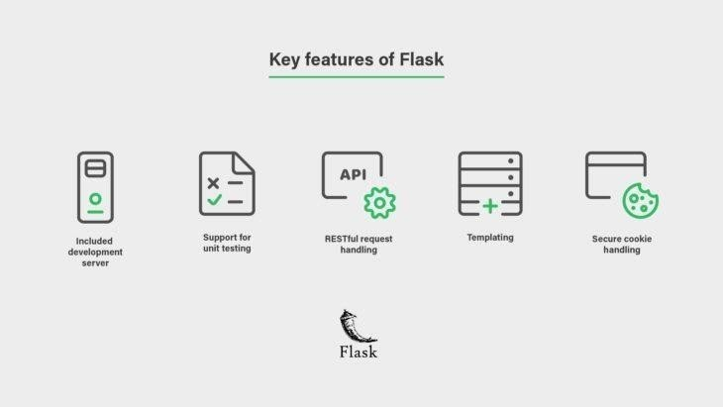

Flask is a web framework that provides libraries to build lightweight web applications in python. It is developed by **Armin Ronacher** who leads an international group of python enthusiasts (POCCO).

# What is Flask?

Flask is a web framework that provides libraries to build lightweight web applications in python. It is developed by **Armin Ronacher** who leads an international group of python enthusiasts (POCCO). It is based on the WSGI toolkit and jinja2 template engine. Flask is considered as a micro framework.

Industries do use Flask but more complex web apps are built on Django. Django's modularity makes it easier for multiple developers to work on different apps in one project. Beginners prefer Flask over Django though, because of its minimalistic design.

For example, the development team at popular companies like **Netflix, Lyft, andReddit** all use Flask as backend development for their mobile and web applications.

**WSGI**

Web Server Gateway Interface (WSGI) has been adopted as a standard for Python web application development. WSGI is a specification for a universal interface between the web server and the web applications.

# Werkzeug

It is a WSGI toolkit, which implements requests, response objects, and other utilityfunctions. This enables building a web framework on top of it. The Flask framework usesWerkzeug as one of its bases.

# Jinja2

Jinja2 is a popular templating engine for Python. A web templating system

combines a template with a certain data source to render dynamic web pages.

Flask is often referred to as a micro framework. It aims to keep the core of an applicationsimple yet

extensible. Flask does not have a built-in abstraction layer for database handling, nor does it have form validation support. Instead, Flask supports the extensions to add such functionality to the application.